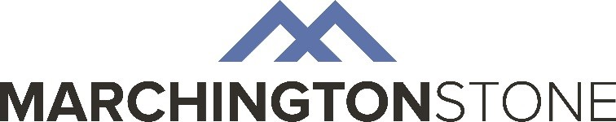
BM-05 ENVIRONMENTAL POLICY STATEMENT

Marchington Stone Ltd is an independent, family owned quarrying company and specialist supplier of aggregates, road-stone, sand, soil, gravel and block stone to the construction and civil engineering industry throughout Great Britain.

Our Company recognises the need to positively manage the impact of its activities on the environment. As such, we are committed to compliance with the applicable legislative requirements and through the implementation of the environmental management system
BS EN ISO 14001:2015.

As an organisation we are committed to continual improvement in our environmental performance and we set defined environmental objectives and targets, based on our significant environmental aspects.

In order to reduce the environmental impacts of our business we shall:

- Take all necessary and practicable steps to prevent pollution;

- Make our vehicle, transport and plant operations as fuel-efficient as possible;

- Work with our customers, suppliers and contractors in order to positively influence their environmental performance;

- Minimise the production of waste, to recycle where practicable and ensure the correct disposal of all remaining materials;

- Demonstrate the efficient use of natural resources, seeking opportunities to minimise waste and to re-use or recycle materials;

- Provide relevant information and training to persons working on our behalf in order to support our environmental management system.

Our Environmental Policy is available to all interested parties via our website and is reviewed regularly as part of our management review process where appropriate corrective and preventive action will be implemented where necessary.

Approved By:

David Marchington Matthew Marchington
Joint Managing Director Joint Managing Director

